**ASSIGNMENT OF LINUX SESSION #3 AND #4**

Q. 1. Make sub directories inside a parent directory by using single mkdir command. (refer figure given below)

Ans. mkdir -p A/{ash.txt, brock.txt, B/C/barry.txt}

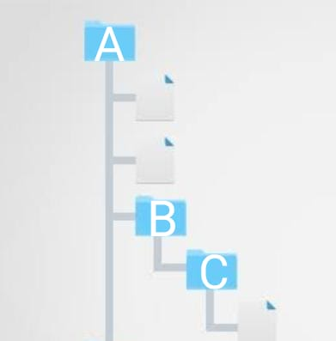

Q. 2. Can we change the Umask value to 0888? If yes, then how. If no then why?

Ans. No, because specific value if all three permissions (rwx) are given is 4+2+1=7. Therefore, highest Umask value can be 777. Beyond this, any value will be considered invalid.

Q. 3. How to add a new user with a unique user id (e.g. 1345) and check out the unique id of that user.

Ans. **To create ->** sudo useradd -u 1345 NewUser

**To check user id ->** id NewUser

Q. 4. (a) How to change the group of any folder?

(b) After this checkout the group name of the files present in that folder.

(c) Try to change the folder and the files present in the folder using a single command.

Ans. mkdir Pokemon

cd /home/rakesh7137/Pokemon

mkdir ASH

touch Squirtle

touch Bulbasaur

cd ..

ls -l **// this will show that group of Pokemon folder is rakesh7137**

sudo chgrp NGRP Pokemon

cd /home/rakesh7137/Pokemon

ls -l

**OUTPUT-**

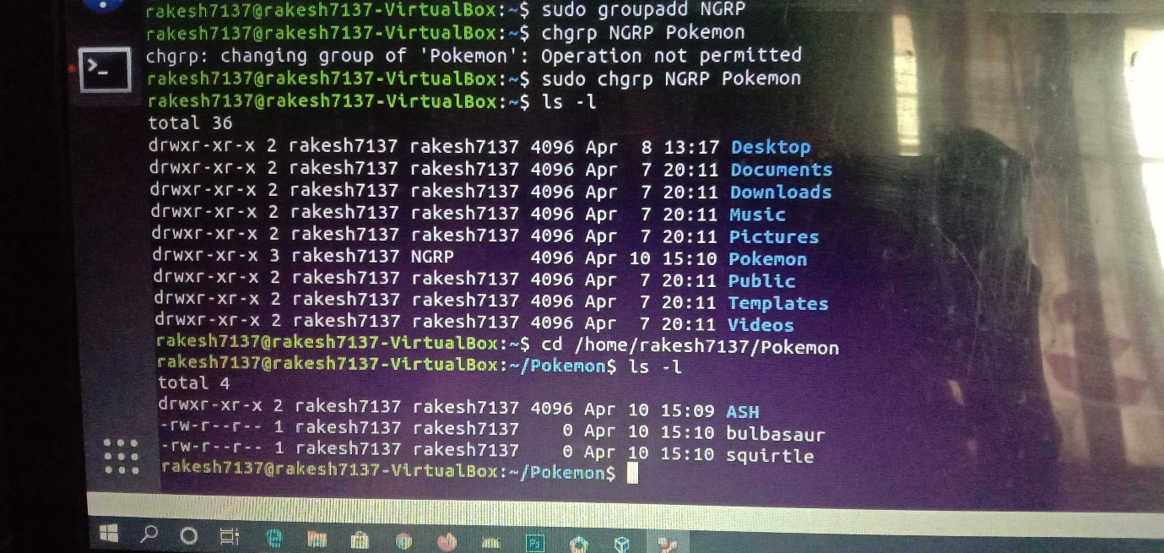

cd ..

sudo chgrp -R NGRP Pokemon

ls -l

**OUTPUT-**

